**MONTAJE DE MI PC**

-Procesador: **AMD Ryzen 5 5600X 3.7GHz**

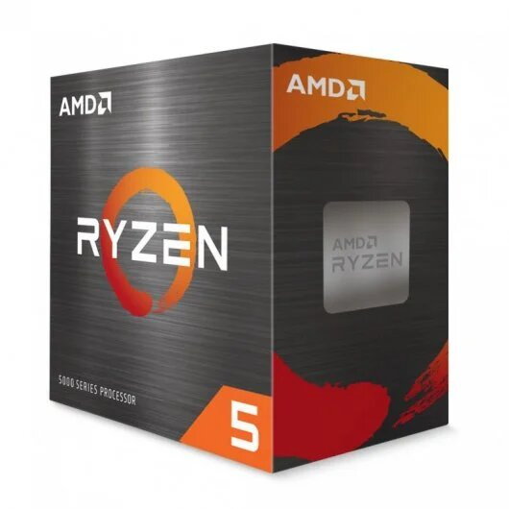

[**https://www.pccomponentes.com/amd-ryzen-5-5600x-37ghz**](https://www.pccomponentes.com/amd-ryzen-5-5600x-37ghz)

Precio: 199,89 euros

**-**Placa base: **Gigabyte B550 AORUS ELITE V2**

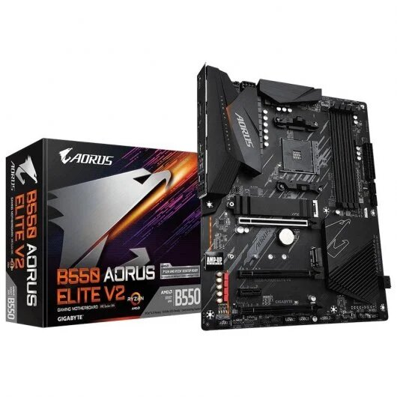

<https://www.pccomponentes.com/gigabyte-b550-aorus-elite-v2>

Precio: 156,90 euros

-Memoria RAM: **Team Group Delta White RGB DDR4 3200 PC4-25600 16GB 2x8GB CL16**

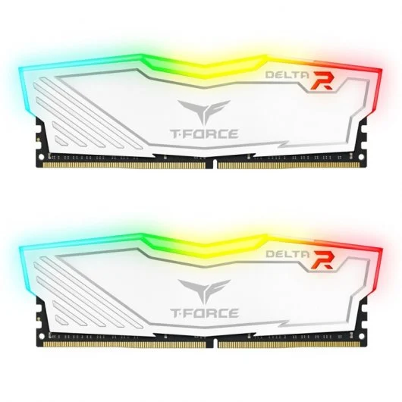

[**https://www.pccomponentes.com/team-group-delta-white-rgb-ddr4-3200-pc4-25600-16gb-2x8gb-cl16**](https://www.pccomponentes.com/team-group-delta-white-rgb-ddr4-3200-pc4-25600-16gb-2x8gb-cl16)

Precio: 67,99 euros

-Caja/Torre: **Tempest Umbra RGB Torre ATX Negra**

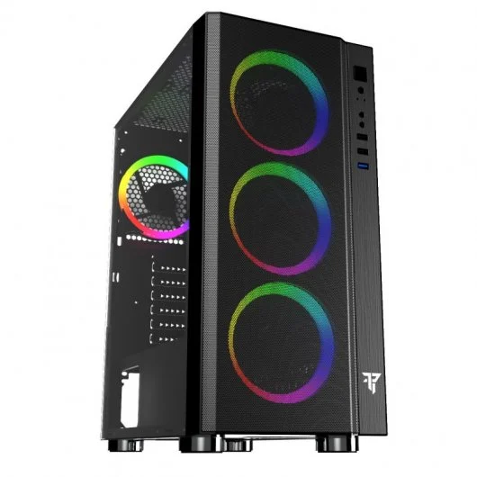

[**https://www.pccomponentes.com/tempest-umbra-rgb-torre-atx-negra**](https://www.pccomponentes.com/tempest-umbra-rgb-torre-atx-negra)

Precio: 69,99 euros

-Ventilador CPU: **Tempest Gaming Liquid Cooler 240 Kit Refrigeración Líquida RGB Blanco**

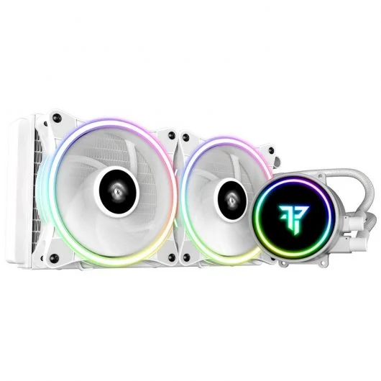

[**https://www.pccomponentes.com/tempest-gaming-liquid-cooler-240-kit-refrigeracion-liquida-rgb-blanco**](https://www.pccomponentes.com/tempest-gaming-liquid-cooler-240-kit-refrigeracion-liquida-rgb-blanco)

Precio: 79,99 euros

-Disco duro 1: **Seagate BarraCuda 3.5" 2TB SATA 3**

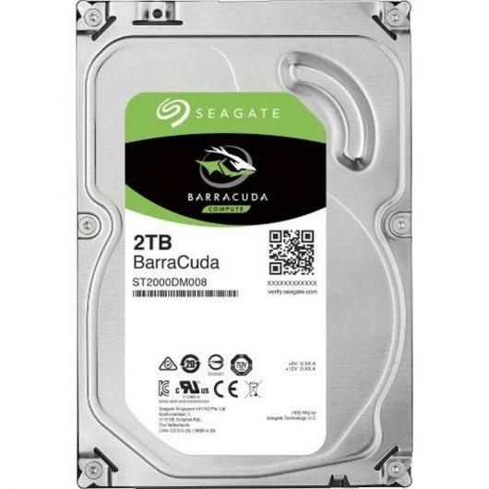

<https://www.pccomponentes.com/seagate-barracuda-35-2tb-sata-3>

Precio: 53,99 euros

-Disco duro 2: **Seagate BarraCuda 3.5" 2TB SATA 3**



<https://www.pccomponentes.com/seagate-barracuda-35-2tb-sata-3>

Precio: 53,99 euros

-Fuente de alimentación: **Corsair CV Series CV650 650W 80 Plus Bronze V2**

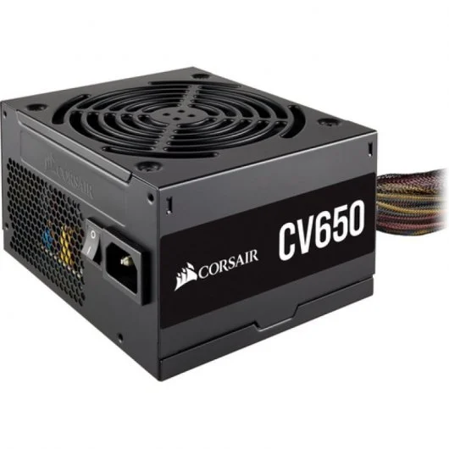

<https://www.pccomponentes.com/corsair-cv-series-cv650-650w-80-plus-bronze-v2>

Precio: 69,99 euros

-Tarjeta gráfica: **ASUS TUF Gaming GeForce GTX 1660 SUPER OC Edition 6GB GDDR6**

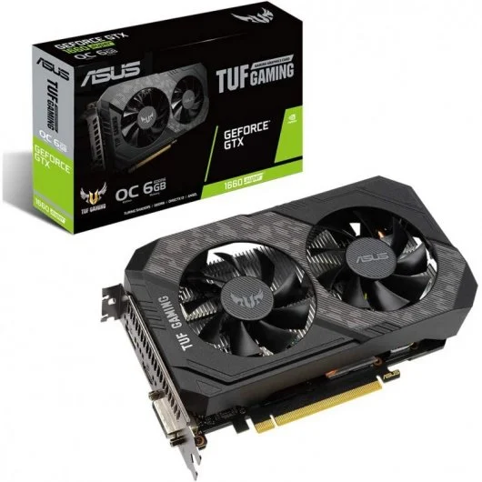

<https://www.pccomponentes.com/asus-tuf-gaming-geforce-gtx-1660-super-oc-edition-6gb-gddr6>

Precio: 289,99 euros

-Monitor: **AOC 24G2SAE/BK 23.8" LED FullHD 165Hz FreeSync Premium**

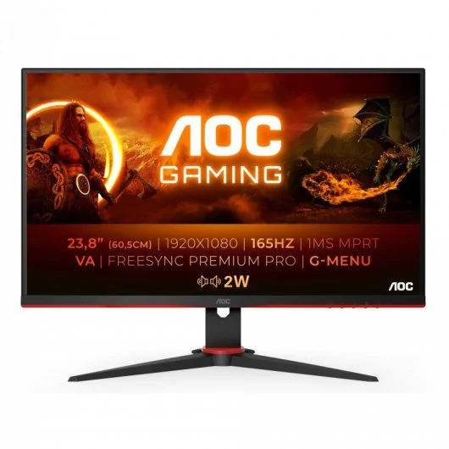

<https://www.pccomponentes.com/aoc-24g2sae-bk-238-led-fullhd-165hz-freesync-premium>

Precio: 189,99 euros

Teclado: **Tempest Doom H-Mech Teclado RGB**

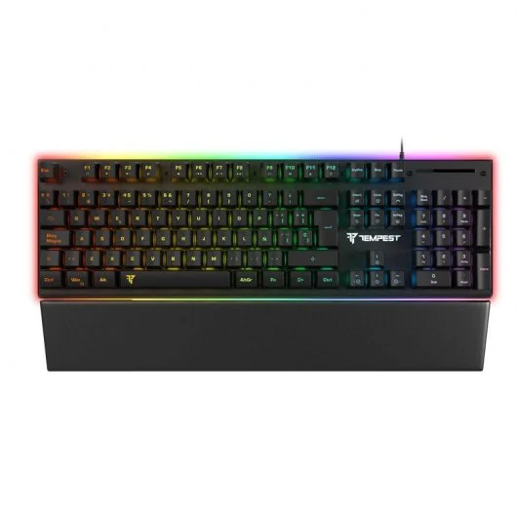

<https://www.pccomponentes.com/tempest-doom-h-mech-teclado-rgb>

Precio: 30 euros

-Ratón: **Asus TUF Gaming M3 Ratón Gaming RGB 7000DPI Reacondicionado**

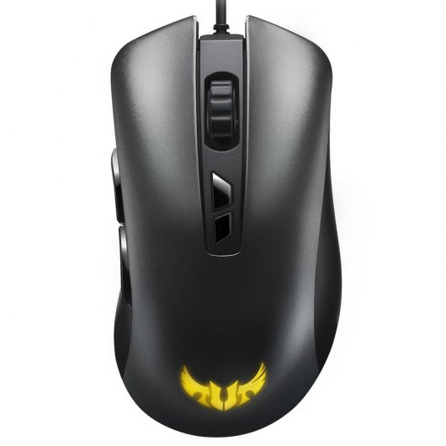

<https://www.pccomponentes.com/asus-tuf-gaming-m3-ratn-gaming-rgb-7000dpi-reacondicionado>

Precio: 22,10 euros

-Sistema operativo: **Microsoft Windows 11 Home Advanced**

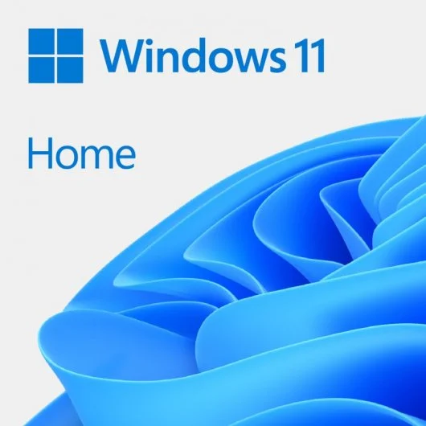

<https://www.pccomponentes.com/microsoft-windows-11-home-advanced>

Precio: 135,99 euros

Precio de todo + instalación del sistema operativo:

1495,74 euros